**WEEK 27 - Period 103**

Date of prepering:

**REVIEW 3 (P3) SHORT STORY**

**I. Aim and objectives:**

- By the end of the lesson Ss can read , listen and understand a short story.

- Skill: listening, speaking , reading, writing .

**II. Teaching aids:**textbook, paper.

**III/ Resources:**

- Student’s book, recording, fresh cards, posters, puppets.

**IV/ Organization:**

|  |  |  |
| --- | --- | --- |
| **Class** | **Date of teaching** | **Absent Ss** |
| 3A |  |  |
| 3B |  |  |

**V/ Procedures**

|  |  |
| --- | --- |
| ***Teacher, s activities*** | ***Ss, s activities*** |
| ***1. Fill the gaps, Then listen and tick (15’)***  - T asks Ss to look at the story on page 38 and help Ss to get the ideal of the story and tells them that they are going to listen and and put the four question in the correct bubbles.  - T plays the CD  - T play the CD again and asks them to and put the four question in the correct bubbles.  Answer:  1.d  2.b  3.c  4.a  ***2.Read the Story aloud (15’)***  - T tells Ss that they are going to read the story aloud in group of four.  *Miu:Who’s Mimi?*  *Chit:She’s my sister.*  *Miu:How many brothers and sisters do you have?*  *Chit:I have two sisters and one brother*  *Miu:Where are they?*  *Chit:They’re here.*  *Miu:This is my sister Mimi and this is my sister Nini.*  *Chit:Hello*  *Mimi and Nini: Hello*  *Miu:And that my brother, Jack.*  *Chit:Hello*  *Jack:Hello*  *Miu:How many rooms are there in your house?*  *Chit:Eight*  *Miu: Eight rooms. That’s a bog house!*  *Chit:Yes, It ‘’s a big mouse house.*  *Miu: A big mouse house.That’s nice.*  *Chit: Yes, It is.*  T monitors and correct their mistake. | Listen and put the four question in the correct bubbles.    Read aloud |

**___________________________________**

**WEEK 27 - Period 104**

Date of prepering:

**REVIEW 3 (P4) SHORT STORY**

**I. Aims and objectives**

**-** By the end of this lesson, students will be able to remember all the knowledge they have learn and do all the exercises

**II. Contents.**

**1**/New words: .

2/Structure:*.*

**III.Teaching aids:** Books, teachers’ book, notebooks, cards and cassette

**IV. Teaching method:** MAT, TPA.

**V. Organization:**

|  |  |  |
| --- | --- | --- |
| **Class** | **Date of teaching** | **Absent Students** |
| **3A** |  |  |
| **3B** |  |  |

**IV/ Procedure**

|  |  |  |  |  |  |  |  |  |  |  |  |  |  |
| --- | --- | --- | --- | --- | --- | --- | --- | --- | --- | --- | --- | --- | --- |
| **1.Warm up and review: (3’)**  - T asks Ss to read aloud story on page 38.  - T monitors and correct their mistakes  2. **New lesson**.  * **Correct the answer. (10’)**  - T introduces the topic “you are going to read the question and correct the answer.  - Give ss time to do the task  Answer:   * + He has two sister.   + He has one brother   + Jack   + There are eight * T calls some pairs to read aloud the question and answer.   **\* Unscramble these word from the conversation. (10’)**  - T asks Ss to put the correct letters to make word.Do the first words as an example:  *a. erstis – Sister*  - T give Ss time to do  Key:   |  |  | | --- | --- | | *a.sister* | *d.rooms* | | *b.brother* | *e.hello* | | *c.house* | *f.mouse* |   - T monitors and correct their mistake  **\* Complete the conversation between Miu and Mimi: (7’)**  - - T introduces the topic “you are going to read the question and fill the gaps  - T give Ss time to do  Key:   |  |  | | --- | --- | | *1.name’s* | *4.to meet you* | | *2.your name* | *5.Nice to meet you* | | *3. name’s* |  |   - T monitors and correct their mistake  **3. Consodilation**  - In this lesson, Ss have reviewed unit 10 from 15.  - Develop reading and writing skills  **4. Home link**  - Have Ss to further practice at home | Read aloud    Read and answer      - Listen and write  -Work individually    work in group  work in pairs. |

_____________________________________

**WEEK 27 - Period 105**

Date of preparing:

**THE MID SECOND TERM TEST**

|  |  |
| --- | --- |
| **PHÒNG GIÁO DỤC VÀ ĐÀO TẠO TRƯỜNG TIỂU HỌC ĐỨC CHÍNH**  **Họ và tên:** …………..……………………  **Lớp**……… | **KIỂM TRA GIỮA HỌC KỲ IINĂM HỌC 2016-2017**  **MÔN TIẾNG ANH- LỚP 3**  **Thời gian: 35 phút** |

|  |  |  |  |  |
| --- | --- | --- | --- | --- |
| ***Marks*** | ***Listening*** | ***Reading and writing*** | ***Speaking*** | ***Total*** |
|  |  |  |  |
|

**PART 1. LISTENING**

**Question 1: Listen and number. (nghe và đánh số)**

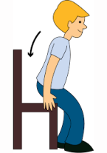

**Question 2: Listen and tick the picture. (Nghe và chọn bức tranh đúng)**

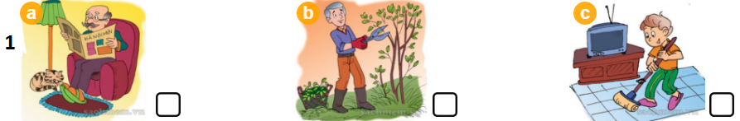

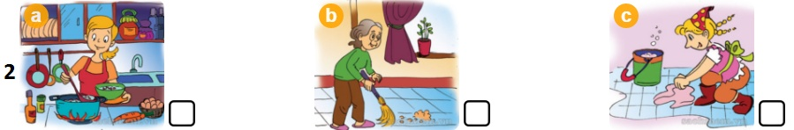

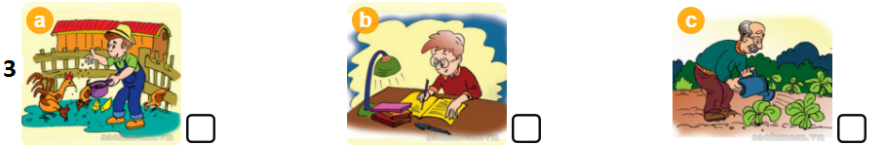

**Question 3: Listen and number. (Nghe và đánh số)**

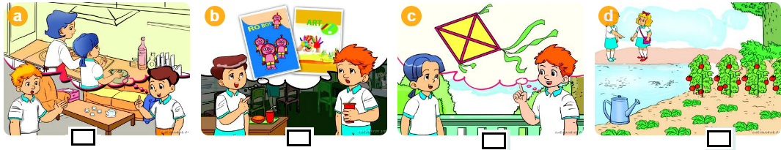

**Question 4: Listen and chose the best answer. (Nghe và chọn đáp án đúng)**

1. How many maps are there in the living room?
2. There are two B. there are three
3. Are there any sofas in the room.

A.Yes, there are B. No, there aren’t

3. Do you have a robot?

A. No, I don’t B. Yes, I do

**PART 2. READING AND WRITING**

**Question 5: Complete the word (nhìn tranh và hoàn thành các từ)**

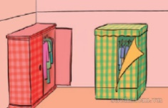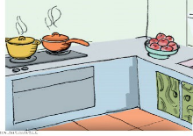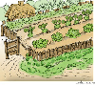

**1. Gr_ _ df_ _ _er 2. g _ _d_ _ 3. K_ _ c _ _ n 4. _ _ _ 5. W_ _ dr_ _ _**

**Question 6: Circle the correct answer (Khoanh tròn đáp đúng)**

1. My name …………….. Peter.

A. is B. are C. do

2. How ………. are you? I am eight years old.

A. is B. are C. old

3. There …………… five balls.

A. is B. are C. do

4. Is there a pond in the garden? - Yes, ……………..

A. there is B. there isn’t C. there are

5. Do you have a ship? - No, …………………….

A. I do B. I don’t C. he does

**Question 7: Read and circle the correct answers (Đọc đoạn văn và chọn câu trả lời đúng)**

My name is Thuy. I am ten years old. There are five people in my family. My grandfather is seventy years old. My father is forty-eight years old. My mother is young, she is thirty-nine years old. My brother is fourteen years old.

1. Thuy is ……….. years old.

A. eight B. nine C. ten

2. Her grandfather is …………… years old

A. fifty B. sixty-seven C. seventy

3. Her ……………… is forty-eight years old.

A. father B. mother C. grandfather

4. Her mother is ………………….

A. young B. old C. nice

**Question 8: Put the words in order (Xếp các từ thành câu hoàn chỉnh)**

1. is/Who/that?- ………………………………………

2. old / How /your father?/ is - …………………………………………………

3. many/How/fans/there?/are- ……………………………………………………

**Question 9: Answer the question about you. (Trả lời câu hỏi về bản thân em)**

1. What’s your name?

___________________________________

2. How old are you?

___________________________________

3. Do you have any toys?

___________________________________

**__________________________**

**WEEK 27 - Period 106**

Date of preparing:

**CORRECT THE MID SECOND TERM TEST**

………………………………………………………………………………………………………………………………...............................................................