**WEEK 27- Period 103**

Date of preparing:

**SHORT STORY (Part 1)**

**I. Aim and objectives:**

- By the end of the lesson Ss can read , listen and understand a short story.

- Skill: listening, speaking , reading, writing .

**II. Teaching aids:**textbook, paper.

**III. Resources:**

- Student’s book, recording, fresh cards, posters, puppets.

**IV. Organization:**

|  |  |  |
| --- | --- | --- |
| **Class** | **Date of teaching** | **Absent Ss** |
| 5B |  |  |

**V. Procedures**

|  |  |
| --- | --- |
| ***Teacher, s activities*** | ***Ss, s activities*** |
| **1. Read and listen to the story (20’)**  - T tells Ss that they are going to read and listen to the story.  *Chit: Good morning Miu. How are you today?*  *Miu:Hello Chit. I’m not well.*  *Chit:What’s the matter with you?*  *Miu:I have a headache, a stomach ache and a fever.*  *Chit:Oh, tat’s terrible. You should go back to bed.*  *Miu:I can’t. I have to go out.*  *Chit:Why?*  *Miu:Because I’m going to the zoo with Maurice and Doris.*  *Miu: Hello, Miu speaking*  *Maurice: Hello, Miu. It’s Maurice here.*  *Miu: Hello, Maurice. How are you?*  *Maurice: I’m ill. And Doris is ill, too. We cant’t go to the zoo. I’m sorry.*  *Miu:Don’t worry Maurice. I’m ill too. We can go to the zoo next week.*  *Miu: Maurice and Doris are ill, too. They can’t go to the zoo.*  *Chit:Good*  *Miu:Good?*  *Chit:Yes, You can stay home and go to bed.*  *-* T monitors and correct their mistake.  **2. Answer the question(15’)**  - Tell Ss that they are going to answer the question.  - Ss answer silently the sentences.  - Ss trade their answers within pairs or groups for correction  - Ask Ss to read the answers aloud to the class. The others listen and give comments.  Key:  *1. No, he isn’t*  *2. He has a headache, a stomach ache & a fever*  *3.He’s going to the zoo*  *4. No, they can’t*  *5. He can’t go to the zoo* | Listen    Read aloud  Read aloud |

**__________________________________________**

**WEEK 27 - Period 104**

Date of preparing:

**SHORT STORY (Part 2)**

**I. Aims and objectives**

**-** By the end of this lesson, students will be able to remember all the knowledge they have learn and do all the exercises

**II. Contents.**

**1**/New words: .

2/Structure:*.*

**III.Teaching aids:** Books, teachers’ book, notebooks, cards and cassette

**IV. Teaching method:** MAT, TPA.

**V. Organization:**

|  |  |  |
| --- | --- | --- |
| **Class** | **Date of teaching** | **Absent Ss** |
| 5A |  |  |
| 5B |  |  |

**IV. Procedure**

|  |  |  |  |  |  |  |  |  |  |  |  |  |  |  |  |  |  |  |
| --- | --- | --- | --- | --- | --- | --- | --- | --- | --- | --- | --- | --- | --- | --- | --- | --- | --- | --- |
| **A.Warm up and review: (3’)**  - T asks Ss to read aloud story on page 38.  - T monitors and correct their mistakes  **B. New lesson**.  3. **Unscramble these words from the story. (10’)**  - T introduces the topic “you are going to read the story and unscramble these words.  - T asks Ss to put the correct letters to make word.Do the first words as an example:  - Give ss time to do the task  *Answer:*   |  |  |  | | --- | --- | --- | | *1.headache* | *2.terrible* | *3.speaking* | | *4.because* | *5.matter* |  |   - T calls some pairs to read aloud the question and answer.  **4. Read and complete (10’)**  - T introduces the topic “you are going to read the and complete.  - T give Ss time to do  Key:   |  |  | | --- | --- | | *1.well* | *4.stay* | | *2.matter* | *5.not* | | *3. have* |  |   - T monitors and correct their mistake  **5. Work in pair**  - T introduces the topic “you are going to work in pair imagine you are sick and talk about how you feel  - T give Ss time to do  - T monitors and correct their mistake  **6.Read and match (7’)**  - T introduces the topic “you are going to read the and match.  - T give Ss time to do  Key:   |  |  |  |  |  | | --- | --- | --- | --- | --- | | *1.e* | *2.a* | *3.b* | *4.c* | *5.d* |   - T monitors and correct their mistake  **C. Consodilation**  - In this lesson, Ss have reviewed unit 11 from 15.  - Develop reading and writing skills  **D. Home link**  - Have Ss to further practice at home | Read aloud    Read and answer      Listen and write  Work individually    Work in group  Work in pairs. |

**WEEK 27 - Period 105**

Date of preparing:

**THE MID SECOND TERM TEST**

|  |  |
| --- | --- |
| **PHÒNG GIÁO DỤC VÀ ĐÀO TẠO TRƯỜNG TIỂU HỌC ĐỨC CHÍNH**  **Họ và tên:** …………………………  **Lớp**……… | **KIỂM TRA GIỮA HỌC KỲ II NĂM HỌC 2016-2017**  **MÔN TIẾNG ANH- LỚP 5**  **Thời gian: 35 phút** |

|  |  |  |  |  |
| --- | --- | --- | --- | --- |
| ***Marks*** | ***Listening*** | ***Reading and writing*** | ***Speaking*** | ***Total*** |
|  |  |  |  |
|

**PART 1. LISTENING**

**Question 1. Listen and tick the word you hear. (Nghe và chọn từ thích hợp)**

1. I have a _________________

A. headache B. toothache

2. You should see a ……………….

A. doctor B. teacher

3. What did you do last _________?

A. Sunday B. summer

4.Would you like to drink some ______________?

A. rice B. milk

5. I’m going to take along some_______________

A, food B. drink

**Question 2. Listen and tick the picture (Nghe và chọn bức tranh đúng)**

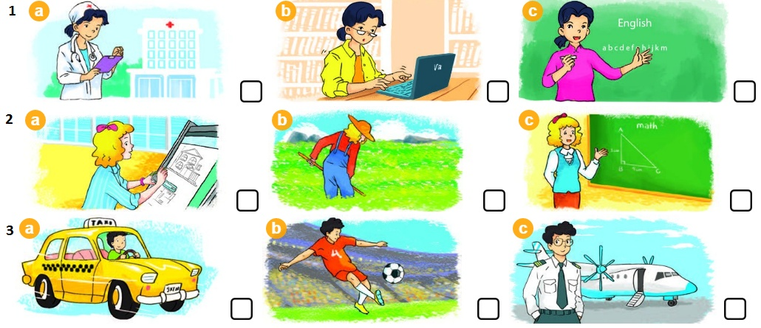

**Question 3**. Listen and match the picture with the name. (nối các tên với các bức tranh)

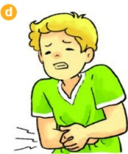

**PART 2. READING AND WRITING**

**Question 4. Look the picture and complete (Nhìn tranh và viết các từ dưới các bức tranh)**

|  |
| --- |
| **doctor teacher stomach ache fever** |

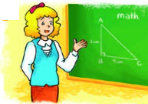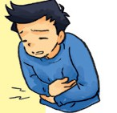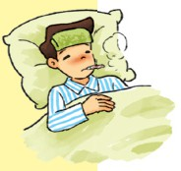

**1. __________ 2. _____________ 3. _____________ 4. _____________**

**Question 5. Read and match (Đọc và nối cột A với cột B và viết vào phần key)**

|  |  |  |
| --- | --- | --- |
| **A** | **B** | **key** |
| 1. Who’s that? | a. He has a headache. | 1.-> …… |
| 2. What’s the matter with Nam? | b. I’d like to be a pilot. | 2.-> …… |
| 3. What’s your address? | c. It’s Miss Hoa. | 3.-> …… |
| 4. What would you like to be in the future? | d. It’s Dinh Hai Village. | 4.-> …… |

**Question 6. Read the passage and tick True or False. (Đọc và tick đúng “T” và sai “F” )**

John lives in England. He is a famous footballer. He likes traveling very much. Last years, he visited Ha Long Bay in Viet Nam. It is very beautiful. Next year, he is going to visit Hoi An. He says he likes Vietnam very much.

1. John lives in the USA.
2. He is a famous footballer.
3. He visited Ha Long Bay last year.
4. He is going to visit Hoi An next year.

**Question 7 . Put the words in order (Xếp các từ thành câu hoàn chỉnh)**

1. her/ What/ name?/ is _______________________________________

2. Where/live? / you/ do _______________________________________

3. the / matter / you? / What’s / with/ _______________________________________

4. do/ you/ What/ do/ your/ free time? / in _______________________________________

**Question 8. Answer the questions about you. (Hãy trả lời về bản thân em.)**

1. What is your name? ______________________________
2. How old are you? ______________________________
3. What do you do? ______________________________
4. Where do you live? _______________________________

**WEEK 27 - Period 106**

Date of preparing:

**CORRECT THE MID SECOND TERM TEST**

**_________________________________________**